Norfolk County Council proposes to make a Temporary Traffic Regulation Order (the “Order”) (STRO14277) affecting the Grange Road from its junction with B1113 Market Place for 20 metres north-westwards (“Road A”) and U33076 Market Place from its junction with B1113 Market Place for 20 metres westwards (“Road B”) in the Parish of New Buckenham to facilitate works to overhead service lines, the Roads A and B will be temporarily closed/restricted (except for pedestrian access) for the duration of the works/period the closure is necessary which is anticipated to be between 08:00 and 18:00 on the 1st May 2026, but may continue to be closed/restricted until the 12th June 2026 where the closure/restriction is still required beyond the anticipated dates.

Alternative route is via: Road A: 33078 Grange Road, 33079 Church Street/ Market Place, B1113 Market Place, 33078 Grange Road, Road B: 33076 Market Place, 33079 Market Place, B1113 Market Place, 33076 Market Place.

The works promoter for this restriction/closure is: UK Power Networks.

Vehicular access will be permitted to a final destination in the Roads A and B where signs indicating such access is possible and permitted are in place.

The Order shall automatically revoke on the completion of the works/when the closure is no longer necessary or otherwise on the 12th June 2026 without further notice.

If necessary, the restriction could run for a maximum period of 18 months from the date the Order is effective.

A person who contravenes, or who uses or permits the use of a vehicle in contravention of the restriction/closure imposed by the Order shall be guilty of an offence.

Penalty: £1000 maximum fine on conviction and/or endorsement for contravention.

In the event of the start date being delayed the new start date will be displayed on site in advance.

Full details on the closure are available at https://one.network. Any enquiries that cannot be answered on the one.network website should be directed to the South Area Streetworks (Infrastructure Department) contactable by telephone at 0344 800 8020 or email at streetworks@norfolk.gov.uk

Dated this 17th day of April 2026.

Katrina Hulatt
Director of Legal Services (nplaw)
County Hall
Martineau Lane
Norwich
NR1 2DH

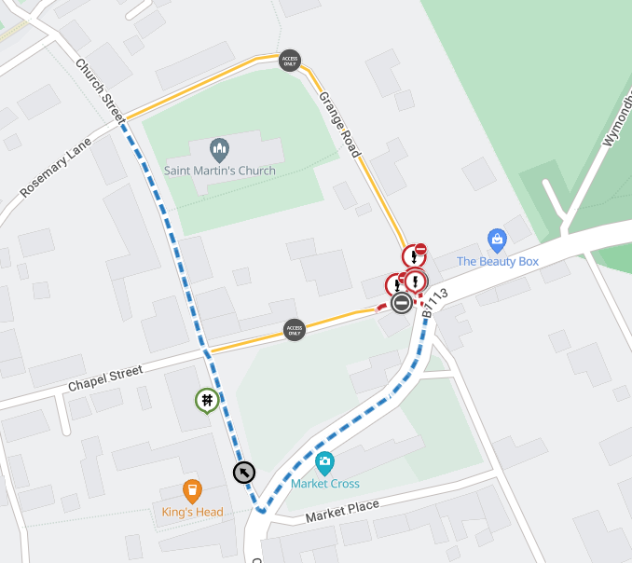

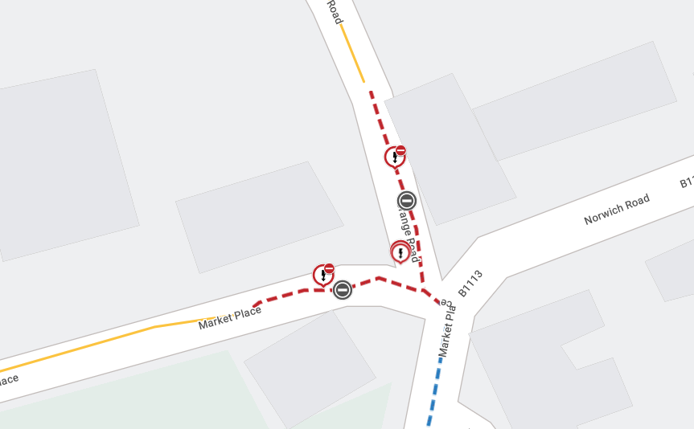

Imagery © 2026 MapTiler | Imagery © 2026 Hexagon | © MapTiler © OpenStreetMap contributors

