Norfolk County Council (New Buckenham)
Emergency Notice

Temporary Traffic Regulation Order 2025
Section 14(2) of the Road Traffic Regulation Act 1984

New Buckenham (STRO13085) Notice

In accordance with the provisions of Section 14(2) of the Road Traffic Regulation Act 1984, the Norfolk County Council HEREBY GIVE NOTICE that owing to defective bridge and boardwalk the use of the New Buckenham Footpath 1 from 225m southwest of its junction with B1113 Norwich Road for 15m south-westwards (the “Footpath”) in the Parish of New Buckenham will be temporarily prohibited/restricted.

Alternative route is via: N/A.

The works promoter for this restriction/closure is: Norfolk County Council.

The closure/restriction is necessary because of the likelihood of danger to the public or serious damage to the footpath or both.

The closure/restriction is anticipated to take place from 2nd to 22nd July 2025.

This Notice shall automatically revoke on the completion of the works / when the closure/restriction is no longer necessary or otherwise on the 22nd July 2025 without further notice.

If necessary, this Notice may be extended for an additional 21 days by further Notice and/or for a maximum of 6 months from the date this Notice is effective by further Order.

A person who contravenes, or who uses the Footpath in contravention of the restriction/ closure imposed by the Order shall be guilty of an offence.

Penalty: £1000 maximum fine on conviction and/or endorsement for contravention.

Full details on the closure are available at https://one.network. Any enquiries that cannot be answered on the one.network website should be directed to the South Area Streetworks (Community and Environmental Services Department) contactable by telephone at 0344 800 8020 or email at streetworks@norfolk.gov.uk

Dated this 2nd day of July 2025.

Katrina Hulatt
Director of Legal Services (nplaw)
County Hall
Martineau Lane
Norwich
NR1 2DH

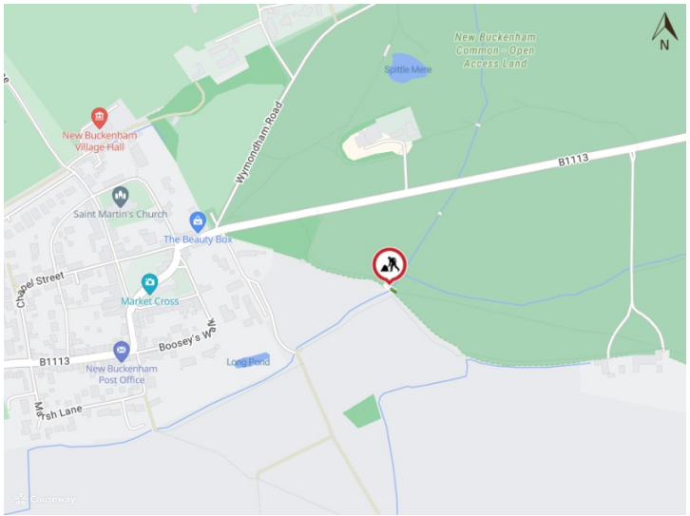

Imagery © 2025 MapTiler | Imagery © 2025 Hexagon | © MapTiler © OpenStreetMap contributors

